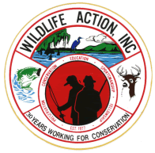 | Wildlife Action, Inc.  Membership / Sponsor Application  P. O. Box 866 Mullins, SC 29574  1-800-753-2264  www.wildlifeaction.com |  |  |  | 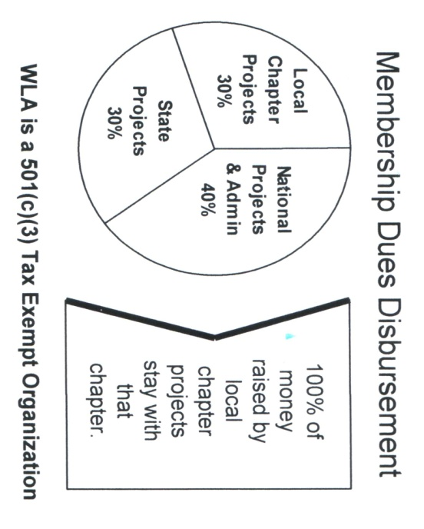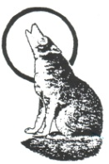
- New Member or Sponsor  - Renewal | MEMBERSHIP LEVELS |  | SPONSOR LEVELS
- New Member or Sponsor  - Renewal | - $30 Individual | - $40 Family | $200 - $ 400 …  $500 - $999 …  $1,000 - $9,000  $10,000 - …… | Guardian  Protector  Conservator  Benefactor
- New Member or Sponsor  - Renewal | - $400 Life | - $600 Family Life | $200 - $ 400 …  $500 - $999 …  $1,000 - $9,000  $10,000 - ……
- New Member or Sponsor  - Renewal | Installment plan available for Life and Family Life Membership, Please check: ◻1 Year ◻2 Year |  | $200 - $ 400 …  $500 - $999 …  $1,000 - $9,000  $10,000 - ……

Name |  |  |  |  |  |  |  | Age |  | Your contributions are tax deductable. Your cancelled check is your receipt.  THANK YOU!!!
Mailing Address
City |  |  |  |  | State |  | Zip
Phone
e-mail

