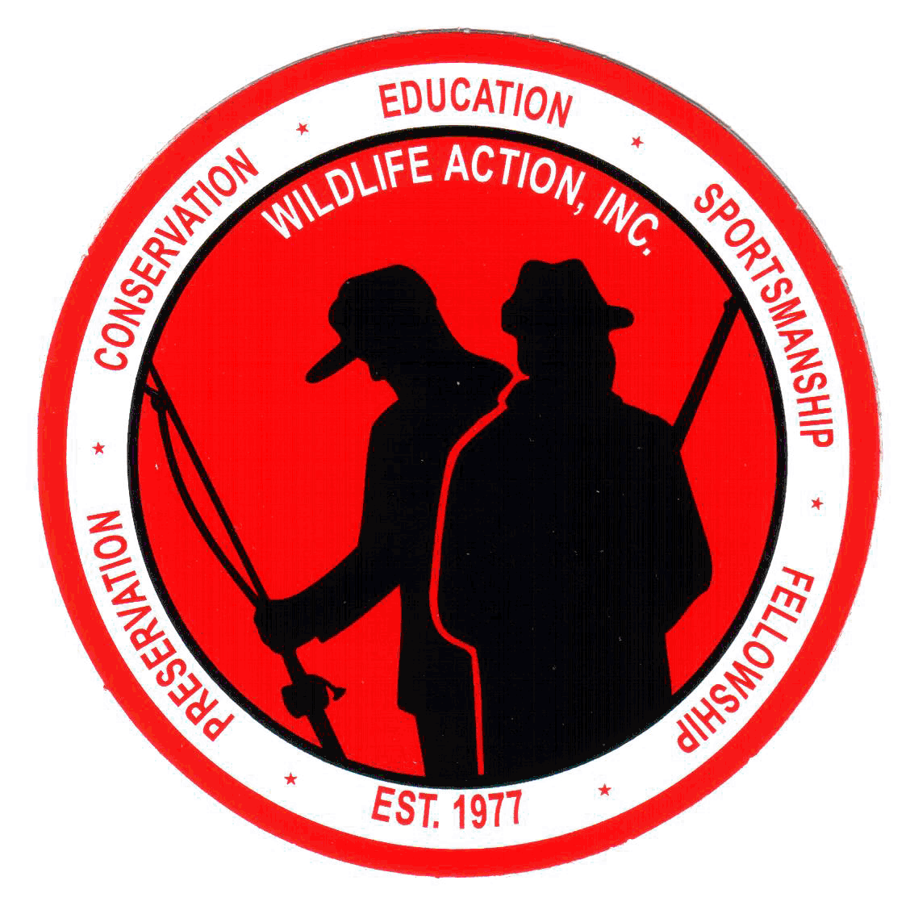 |  |  |  |  |  | Wildlife Action  State Chapter Responsibilities
As a non-profit 501 (c)(3) organization, all funds which come into our possession from any source and by any method, shall be used exclusively for conservation – related purposes consistent with Wildlife Action. Funds will not be given to any other organization unless approved by the National CEO. Funds shall not be allowed to constitute a profit for our chapter members.
I hereby attest that the officers have read the constitution and will abide by it, both in word and deed, and that our responsibilities will be completed by this chapter. I further understand that at any time these requirements are not followed, the National CEO has the authority to place our chapter on probation or revoke our application.
Yes, we will!
 |  |  | (chapter president signature)
CHATPER NAME: WILDLIFE ACTION OF
P.O. BOX: |  |  |  |  | CITY: |  |  |  |  |  |  | STATE: |  |  |  |  | ZIP:
BANK NAME: |  |  |  |  |  |  |  |  |  | CHECKING ACCOUNT #:
BANK ADDRESS: |  |  |  |  |  |  |  |  | CITY: |  |  |  |  | STATE: |  |  |  | ZIP:
Yes, WE UNDERSTAND that we must be active and the following men and women will lead our chapter.
TITLE | NAME | PHONE (H) | PHONE(O)
(Mandatory Positions)
President
Vice President
Secretary
Treasurer
BM 3
BM 3
BM 3
BM 2
BM 2
BM 2
BM 1
BM 1
BM 1
Sr. VP Education
Sr. VP Environment
Sr. VP Fishing
Sr. VP Hunting
Yes, WE UNDERSTAND that we are hunters, fishermen and environmentalists and we will work together to solve any and all local problems in these areas.
INTENT: The intent of Wildlife Action shall be to promote the preservation and conservation of all wildlife, fish and game; to education all sportsmen and the general public in the love of wildlife; to promote and protect the growth of our native trees and wildflowers; to encourage fellowship amount all sportsmen in our endeavor to involve them in civic service; to bring about our own spirit of communication with all of God’s creations.

Yes, WE REALIZE that administrative duties are a valuable part of our organization. In order to become a STATE ASSOCIATE CHAPTER of Wildlife Action, Inc. and continue in good standing, it is our obligation to meet the following criteria within the designated time frame specified by Wildlife Action, Inc.

 |  | Our chapter will have 17 officers/board members
 |  | Our chapter will acquire a post office box.
 |  | Our chapter will open a checking account. Federal ID #570044167
 |  | Our chapter officers and board members will meet the 1st month of every quarter. Our membership will be invited. This may be a business meeting with program, meal, etc.
 |  | Our chapter will mail a newsletter the 2nd month of every each quarter to all members living in the state and to the Pride editor to announce the next meeting, list accomplishments, projects, etc.
 |  | Our secretary will send a copy of our minutes on form #10 to national after each board meeting.
 |  | Our treasurer will send a copy of our financial report and inventory control report on form #11 to national each month.
 |  | Our chapter will form two committees in January to use as needed: ethics; nominating.
 |  | Our chapter will open a land acquisition fund (savings account).
 |  | We understand our chapter will be billed for our state charter fee.
 |  | We understand our chapter will be billed for Pride ad.
 |  | We understand our chapter will be billed for mailing labels.
 |  | Our inventory list from national is |  | Is not correct |  | and must be returned to National.
 |  | We understand form #4, State Chapter Responsibilities, will be completed annually by our chapter president and returned to national by December 31st. Our project money will be withheld from our chapter if we have not completed our obligations above.

NATIONAL OFFICE USE ONLY:
PRESIDENT/CEO APPROVED: |  |  | NOT APPROVED: |  |  | DATE:
CHAPTER MEMBERSHIP #: |  |  | SISTER CHAPTER:
Because you have agreed to meet the above responsibilities, WLA National agrees to the following:
- New Chapters – additional materials may be purchased
- $200.00 |  |  |  | - Patches |  |  |  | - Radio PSA
- Stationery |  |  |  | - Decals |  |  |  | - Form #8 – WLA book
- Brochures |  |  |  | - TV PSA |  |  |  | - Video on history
- All Chapters
- National will send 30% of membership dues back to your chapter within 30 days.
- National will assist in any way possible for the advancement of WLA.

